Assignment- 11.5
2303A51574
BATCH-29
Lab 11 Data Structures with AI Implementing Fundamental
Structures
Lab Objectives
- Use AI to assist in designing and implementing fundamental data structures in Python.
- Learn how to prompt AI for structure creation, optimization, and documentation.
- Improve understanding of Lists, Stacks, Queues, Linked Lists, Trees, Graphs, and Hash Tables.
- Enhance code quality with AI-generated comments and performance suggestions.
Task Description #1 Stack Implementation
Task: Use AI to generate a Stack class with push, pop, peek, and is_empty methods. Sample Input Code: class Stack:
pass
Expected Output:
- A functional stack implementation with all required methods and docstrings.
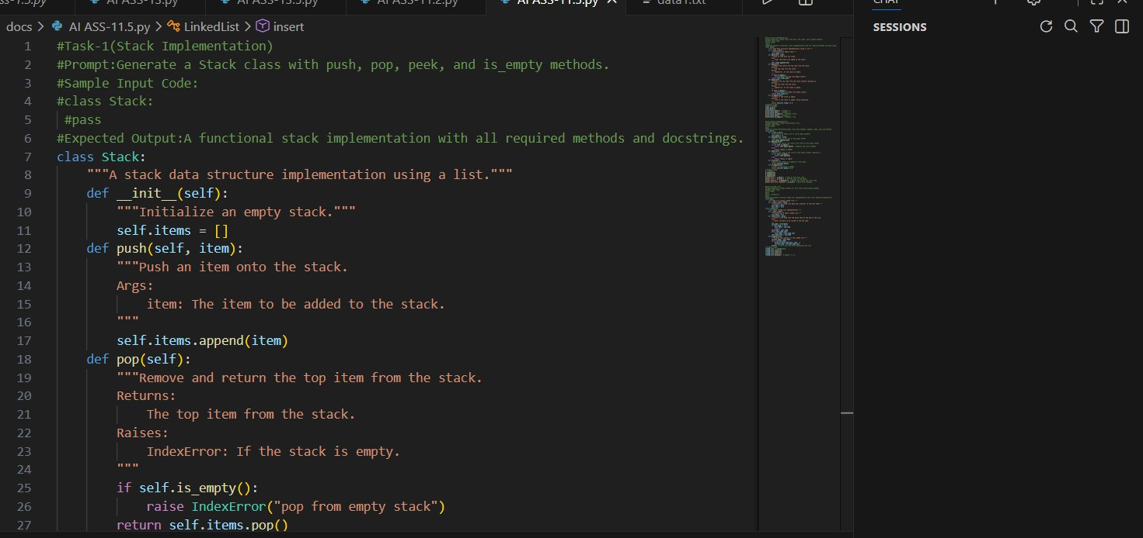
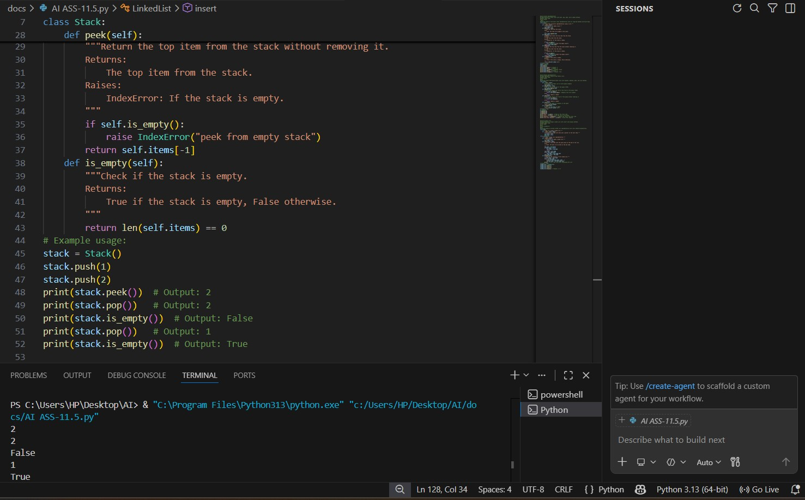
Task Description #2 Queue Implementation Task: Use AI to implement a Queue using Python lists.
Sample Input Code: class Queue:
pass
Expected Output:
- FIFO-based queue class with enqueue, dequeue, peek, and size methods.
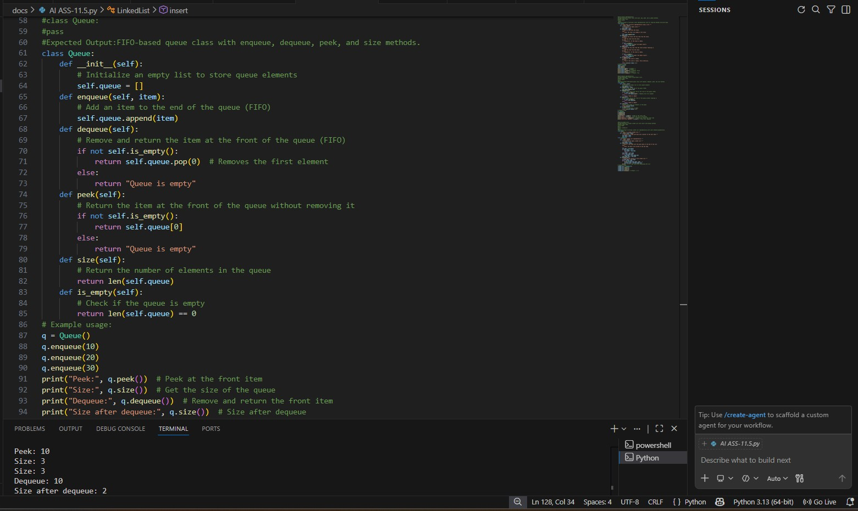
Task Description #3 Linked List
Task: Use AI to generate a Singly Linked List with insert and display methods. Sample Input Code:
class Node: pass class LinkedList: pass
Expected Output:
- A working linked list implementation with clear method documentation
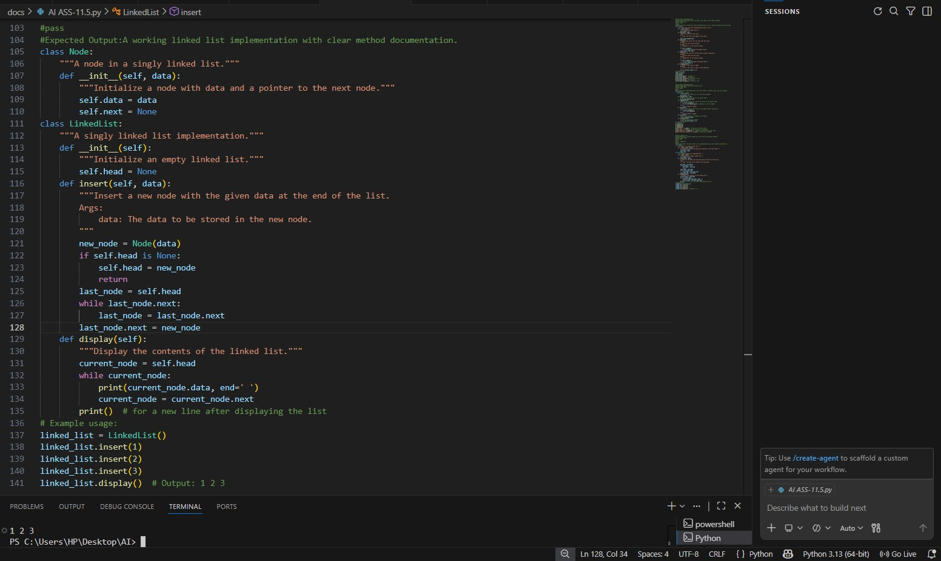
Task Description #4 Hash Table
Task: Use AI to implement a hash table with basic insert, search, and delete methods. Sample Input Code: class HashTable:
pass
Expected Output:
- Collision handling using chaining, with well-commented methods.
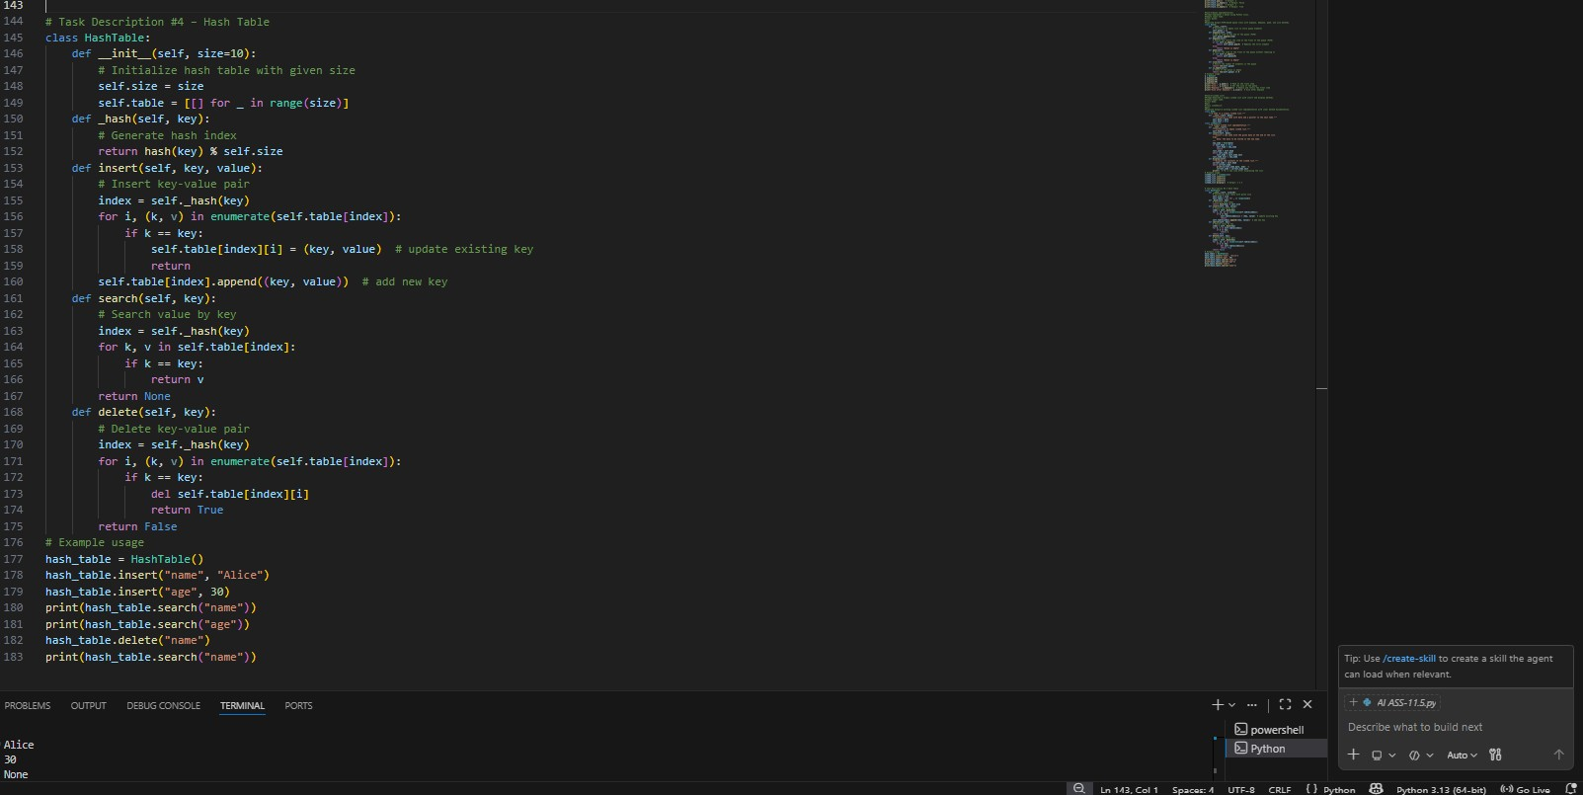
Task Description #5 Graph Representation
Task: Use AI to implement a graph using an adjacency list.
Sample Input Code:
class Graph:
pass
Expected Output:
- Graph with methods to add vertices, add edges, and display connections.
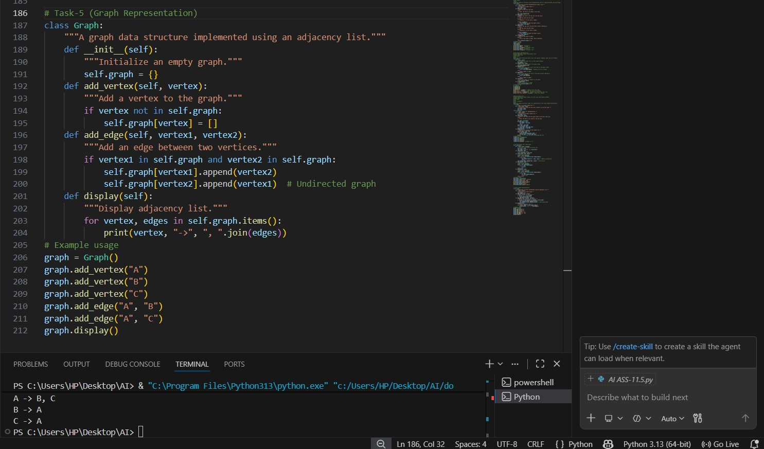
Task Description #6 Smart Hospital Management System – Data Structure Selection
A hospital wants to develop a Smart Hospital Management System that handles:
Patient Check-In System – Patients are registered and treated in order of arrival.
Emergency Case Handling – Critical patients must be treated first.
Medical Records Storage – Fast retrieval of patient details using ID.
Doctor Appointment Scheduling – Appointments sorted by time.
Hospital Room Navigation – Represent connections between wards and rooms.
Student Task
- For each feature, select the most appropriate data structure from the list below: o Stack o Queue o Priority Queue o Linked List o Binary Search Tree BST o Graph o Hash Table o Deque
- Justify your choice in 2 3 sentences per feature.
- Implement one selected feature as a working Python program with AI-assisted code generation.
Expected Output:
- A table mapping feature → chosen data structure → justification. • A functional Python program implementing the chosen feature with comments and docstrings.
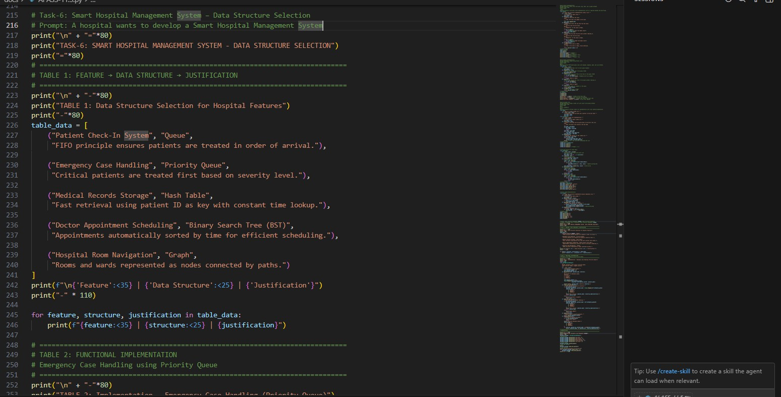
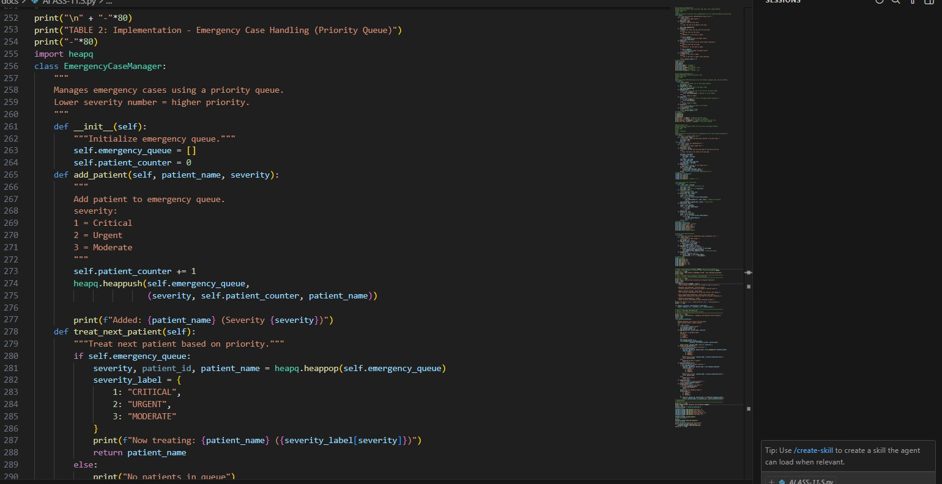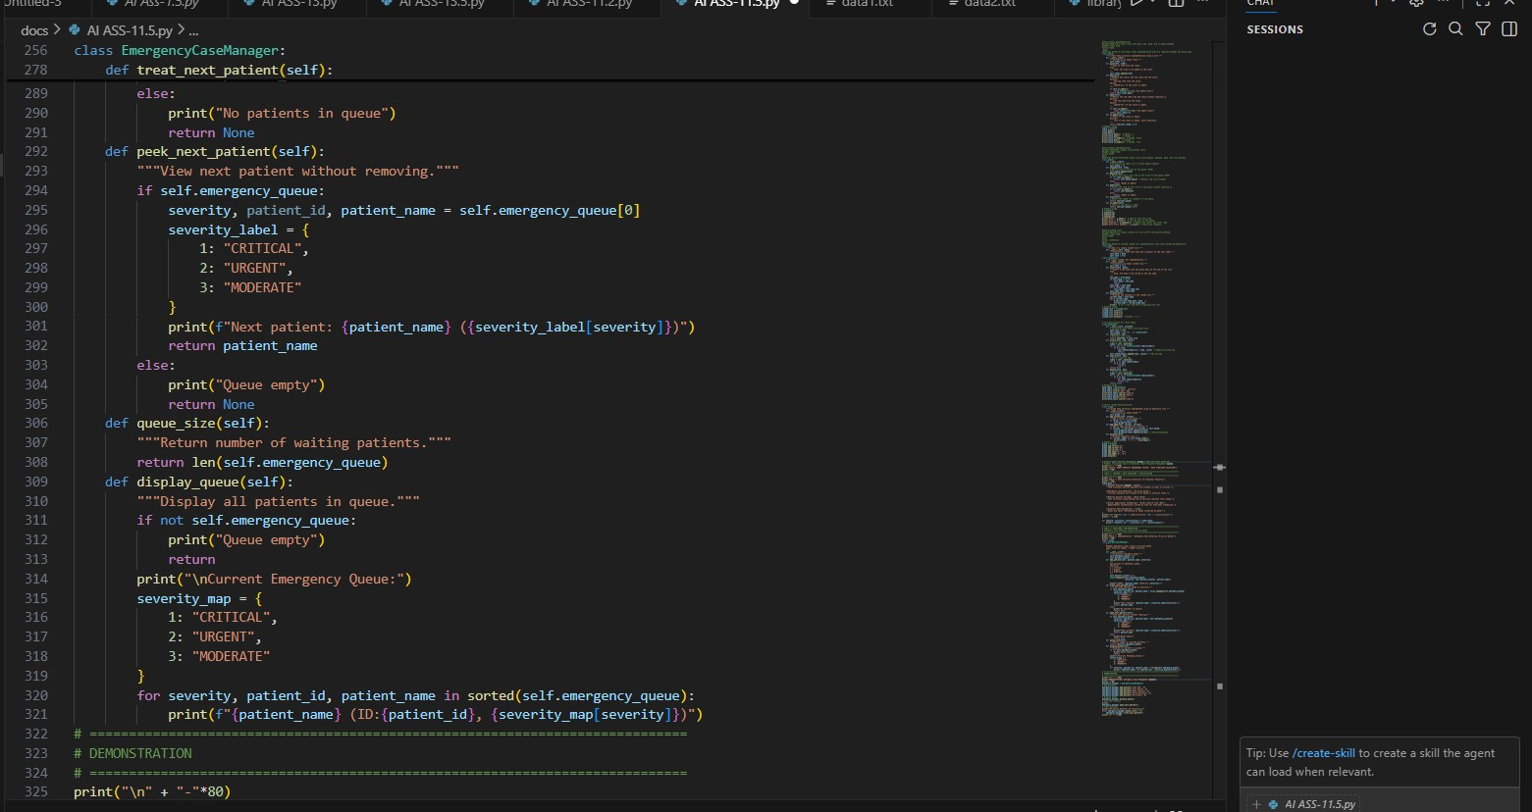
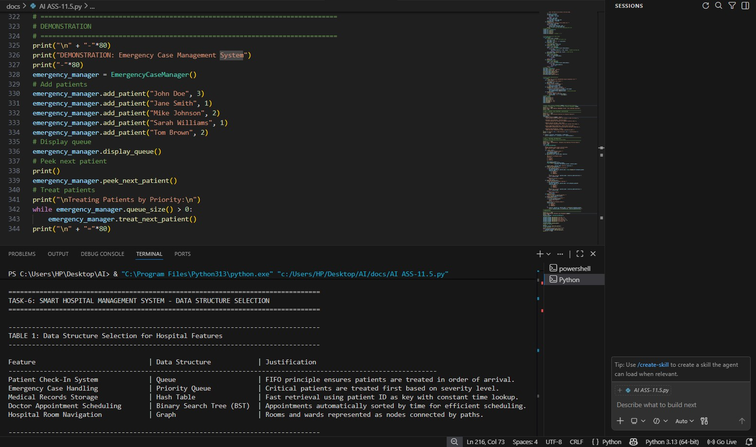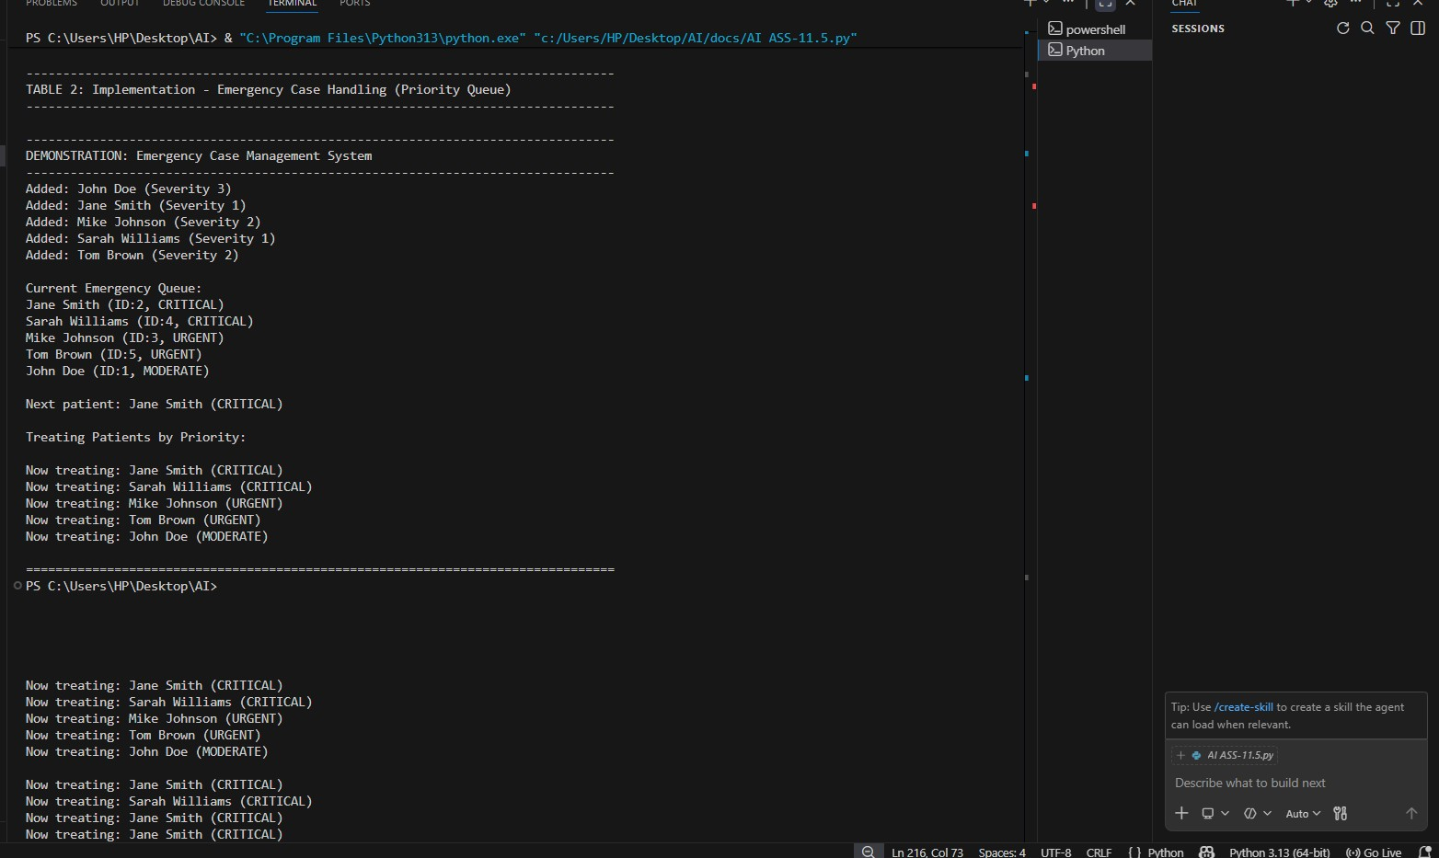
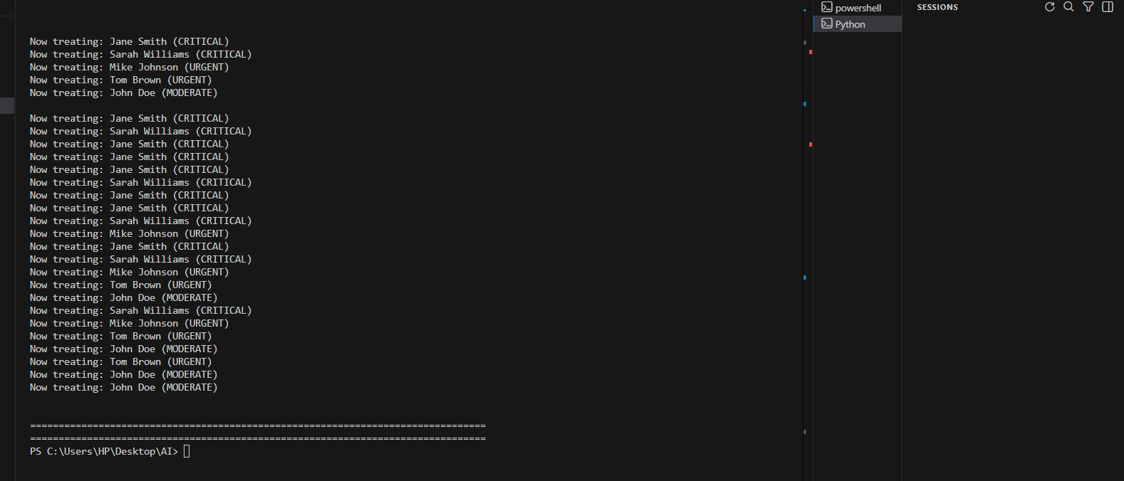
Task Description #7 Smart City Traffic Control System
A city plans a Smart Traffic Management System that includes:
Traffic Signal Queue – Vehicles waiting at signals.
Emergency Vehicle Priority Handling – Ambulances and fire trucks prioritized.
Vehicle Registration Lookup – Instant access to vehicle details.
Road Network Mapping – Roads and intersections connected logically.
Parking Slot Availability – Track available and occupied slots.
Student Task
- For each feature, select the most appropriate data structure from the list below: o Stack o Queue o Priority Queue o Linked List o Binary Search Tree BST o Graph o Hash Table o Deque
- Justify your choice in 2 3 sentences per feature.
- Implement one selected feature as a working Python program with AI-assisted code generation.
Expected Output:
- A table mapping feature → chosen data structure → justification.
- A functional Python program implementing the chosen feature with comments and docstrings.
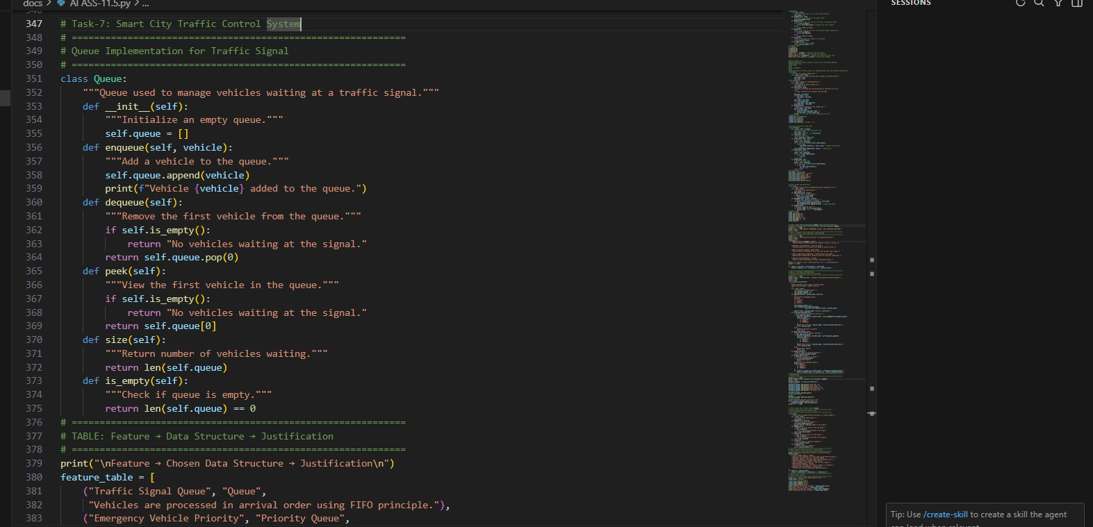
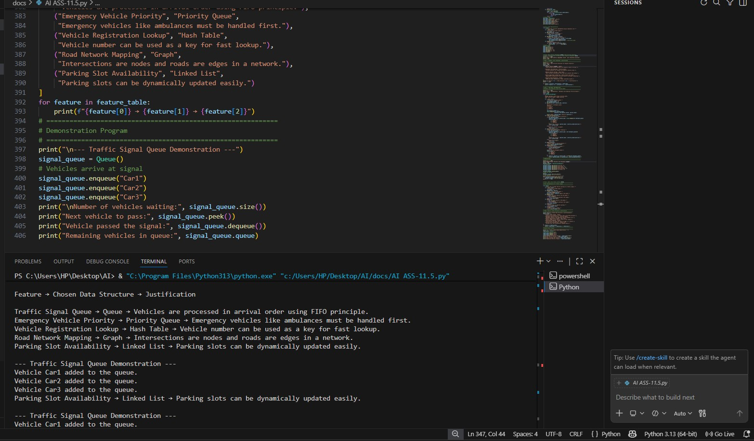
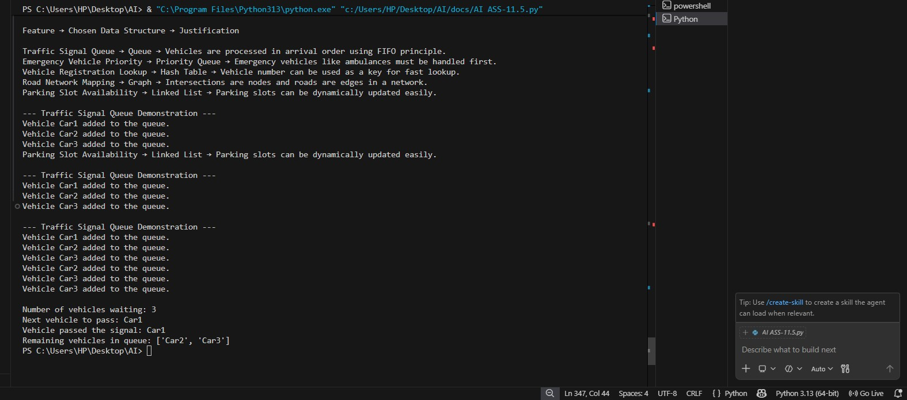
Task Description #8 Smart E Commerce Platform – Data Structure Challenge
An e-commerce company wants to build a Smart Online Shopping System with:
Shopping Cart Management – Add and remove products dynamically.
Order Processing System – Orders processed in the order they are placed.
Top-Selling Products Tracker – Products ranked by sales count.
Product Search Engine – Fast lookup of products using product ID.
Delivery Route Planning – Connect warehouses and delivery locations.
Student Task
- For each feature, select the most appropriate data structure from the list below: o Stack o Queue o Priority Queue o Linked List o Binary Search Tree BST o Graph o Hash Table o Deque
- Justify your choice in 2 3 sentences per feature.
- Implement one selected feature as a working Python program with AI-assisted code generation.
Expected Output:
- A table mapping feature → chosen data structure → justification. • A functional Python program implementing the chosen feature with comments and docstrings.
